Q1.Create a new Jenkins Freestyle project that pulls code from your GitHub repository and builds it using Maven (clean package). Expected Output: Jenkins job builds the project successfully.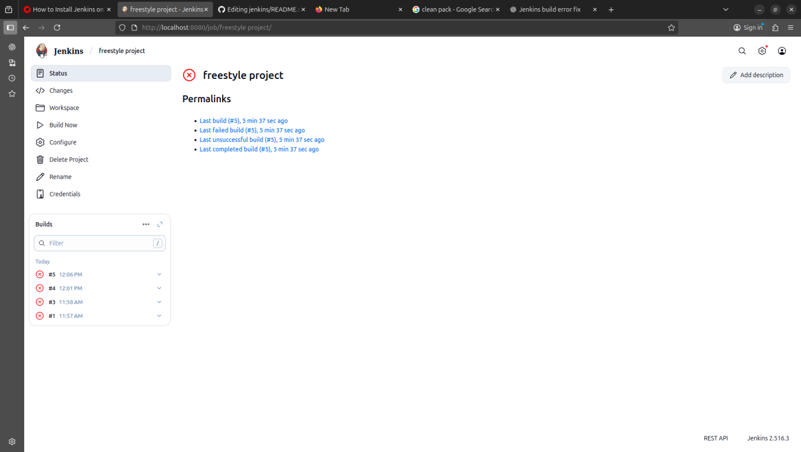

Q2. (15 Marks) Configure Jenkins to automatically trigger a build whenever new code is pushed to GitHub using a webhook. Expected Output: Jenkins job triggers automatically on every commit.

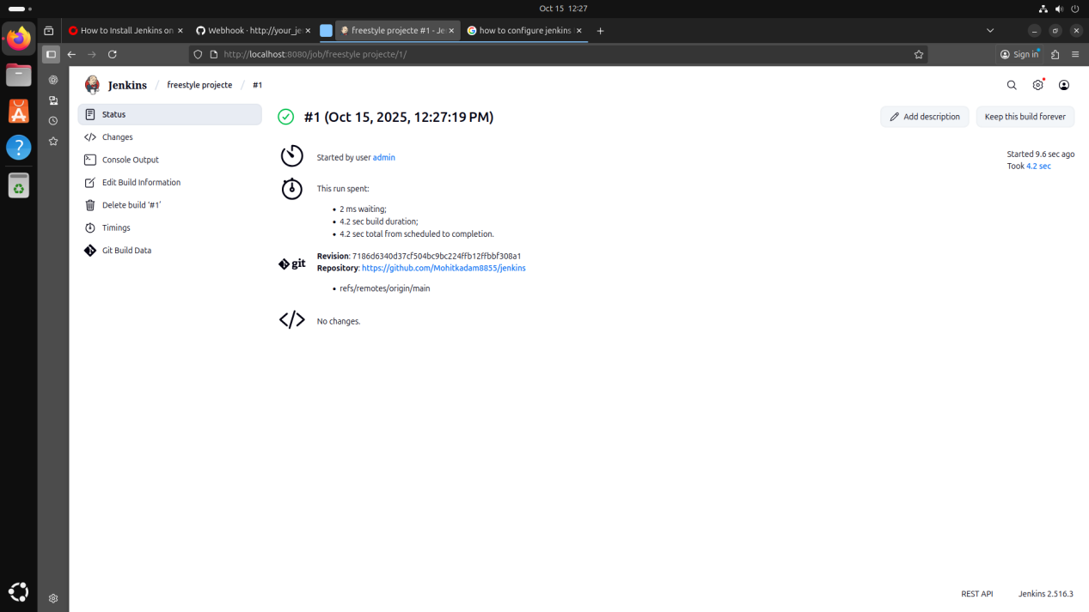

Q3. (10 Marks) Run a container from a Docker image and verify it using docker ps and container logs. Expected Output: Container running successfully with correct output.

